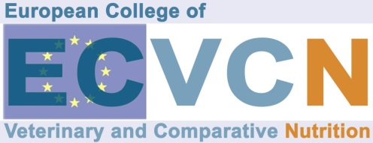

Application for approval of a training programme

Name of training department
Type of programme offered | Specialized training Alternative training
ECVCN Diplomate(s)
Responsible for the programme
Address
Telephone
Fax
e-mail
Date of application
If training is not provided totally on one single site, indicate for each site:
Name of training department
Part of the programme/duration
Person responsible/qualification
Address
Telephone
Fax
e-mail
A/ Training team
Submit detailed list of members of
- academic team, with speciality and possibilities of training in research (do not have to be diplomats)
- technical and support staff, with involvement in training

B/ Methods for training

Teaching activities (theoretical and practical) including didactic methods

Facilities, services and equipment available for training:

Model of log for recording activities by trainees:
Documentation and verification of the Residency Program: Residents are required to maintain an “Activity Log Book” indicting training steps, results achieved, clinical services provided, and seminars and lectures attended. The Program Director, Resident Advisor, Resident and the European College have responsibilities for documentation and verification of satisfactory training for each resident.

.
C/ Laboratory equipment
Submit detailed information about
Routine laboratory methods and laboratory methods provided for special research

Available supportive laboratory methods provided by other institutions
GLP – evaluation methods to ensure a good laboratory praxis
D/ Teaching material available
Number of cases of feed investigations available and laboratory analyses performed during the last 2 years and number of cases of nutritional support either demanded from clinic patients or from outside clients (veterinarians, animal owners) during the last 2 years
.
Books, journals, informatic resources available for training
Statistical methods – support available at the university/faculty
E/ Participation in teaching
Submit information about candidate’s involvement in teaching of veterinary nutrition to undergraduates, in continuous education for practitioners, etc.

F/ Research

Date:

PLEASE EMAIL THIS FORM TO:  Chair of the ECVCN Education and Residency Committee  Dr. Rebecca Ricci  email: Rebecca.ricci@unipd.it  Rebecca Ricci, DVM, PhD  Dept. of Animal Medicine Productions and Health  Università degli Studi di Padova  Viale dell’Università 16,  35020 Legnaro (PD), Italy  Phone +39 0498272656  Don’t forget to ask for a read receipt! | ADD IN CC:  ECVCN Executive Secretary:  Dr. Marco Fantinati  email: marco.fantinati86@gmail.com  Marco Fantinati, DVM, Dipl. ECVCN  Global R&D and Scientific Affair Manager  Farmina Pet Foods, Italy  phone: +39 3497552152
For ECVCN use only
Date received:
Re-certification approved: Yes No Date:

