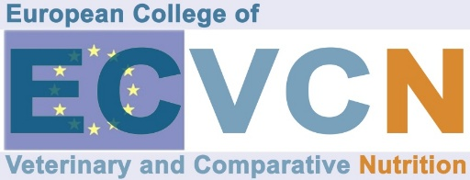

Application for Acknowledgment of the Internship

Please fill out this form and email this together with a copy of your veterinary diploma and your curriculum vitae to the ECVCN Executive Secretary and the Chair of the ECVCN Credential Committee.

DATE OF APPLICATION:

THE APPLICANT
Name of the applicant:
Address:
Telephone:
Fax:
E-mail:

Education:
I possess a European DVM/VMD or equivalent degree from a veterinary college/faculty/university.
Institution (Name/Place):
Approved by EAEVE: Yes No
Date of graduation:
I am licensed to practice veterinary medicine and surgery in the European Union
Yes No
THE LOCATION
Department/institute/location where you have completed your internship. If there is more than one site, please provide information of every site.

1. Name of training department:
Duration of the internship:
Supervisor name:
Supervisor qualifications:
Address:
Telephone:
Fax:
Email:

2. Name of training department:
Duration of the internship:
Supervisor name:
Supervisor qualifications:
Address:
Telephone:
Fax:
Email:

3. Name of training department:
Duration of the internship:
Supervisor name:
Supervisor qualifications:
Address:
Telephone:
Fax:
Email:

DESCRIPTION OF THE INTERNSHIP

Please provide a short description in the sections below. Provide any extra documentation as necessary.

A/ Research work

B/ Number of cases of feed investigations and/or number of cases of nutritional support either demanded from clinic patients or from outside clients (veterinarians, animal owners) you have worked out

C/ Case description(s) if available

D/ Lectures and oral presentations

E/ Education of undergraduates

F/ Analytical methods you have already worked with

PLEASE EMAIL THIS FORM TO:  Chair of the ECVCN Credential Committee:  Dr. Sarah Dodd  email: dr.sarahdodd@gmail.com  Sarah Dodd BVSc, MSc, PhD, Dipl. ECVCN  Dodd Veterinary Services2098 Bidwell Rd, Manitowaning, ON P0P 1N0 Canada  phone: +1 416 830 9064  Don’t forget to ask for a read receipt! | ADD IN CC:  ECVCN Executive Secretary:  Dr. Marco Fantinati  email: marco.fantinati86@gmail.com  Marco Fantinati, DVM, Dipl. ECVCN  Global R&D and Scientific Affair Manager  Farmina Pet Foods, Italy  phone: +39 3497552152
For ECVCN use only
Date received:
Internship approved: Yes No Date:

